# CPRG-352 - Web Application Programming

## Lab 4

## Topic: Java Beans and JSP

In this lab, we will create a very simple partially-complete CRUD web application with a text file backend. The web application will allow the user to view (read) and edit (update) a note. (Create and delete will not be supported at this time.) A note will consist of a title, contents.

### Architecture

Create a new web application called “**Lab4_SimpleNoteKeeper**”.

Add an empty file to /WEB-INF called note.txt which will be used for storing the note details. Add the following two lines to the file:

This is the title  
Contents go here

Add two JSPs named viewnote.jsp and editnote.jsp in /WEB-INF.

Add one servlet named NoteServlet.java in the package servlets.

Add one Java Bean named Note.java in the package domain.

The application has one URL /note that is mapped to NoteServlet.

### Screenshots

**Screenshot when the application starts:**

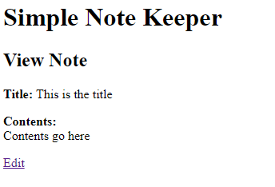

**User clicks edit:**

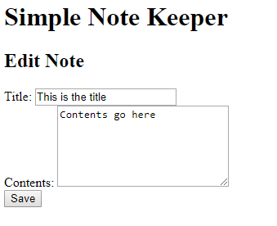

**The edits the title and contents fields and clicks save:**

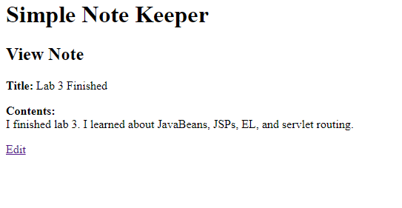

### Requirements

1. You must use a JavaBean to populate the view and edit pages.
2. The JavaBean Note.java must have two strings: one for title and one for contents
3. The servlet must use doGet() for displaying the form in the view or edit mode.
4. The servlet must use doPost() for saving the form from the edit mode.
5. The text file note.txt has exactly two lines. The first line is the title; the second line are the contents.

### Hints

1. Accessing files from a servlet is a bit different than from a Java application. In particular, the path of the file is relative to the project root. Here is some code to help you:

String path = getServletContext().getRealPath("/WEB-INF/note.txt");

// to read files  
BufferedReader br = new BufferedReader(new FileReader(new File(path)));

// to write to a file  
PrintWriter pw = new PrintWriter(new BufferedWriter(new FileWriter(path, false)));

**Do not hardcode any file paths in your project** since it would not work on another computer.

1. The edit link can be written as <a href="note?edit"> and the edit parameter can be used to determine which JSP to display.

### Questions to consider

Run your web application and make a change to the note. Are the changes reflected in note.txt in NetBeans? Using File Explorer, find your note.txt file and open it. Are the changes seen here? Is there another note.txt somewhere in your project folder? What happens if you “clean and build” the project and then run it again? What does the green “play” button do?

### Extra time?

The following items are optional and only if you have enough lab time remaining.

1. Add in delete and create operations.
2. You will probably notice that line breaks do not display properly in the view mode. Examine the source code of the page to determine why. To fix this issue, before doing a setAttribute of the note and displaying the viewnote.jsp, replace the line breaks with <br> in the servlet. (Don’t change the contents within the file!)